**Host Webpage on Github**

This document will demonstrate to you how to register and upload file into Github using the windows GUI and also command line.

**1. Registration**

Before we upload any document into Github, we need to create a github account. Below shows the step of how it can be done.

Step 1.

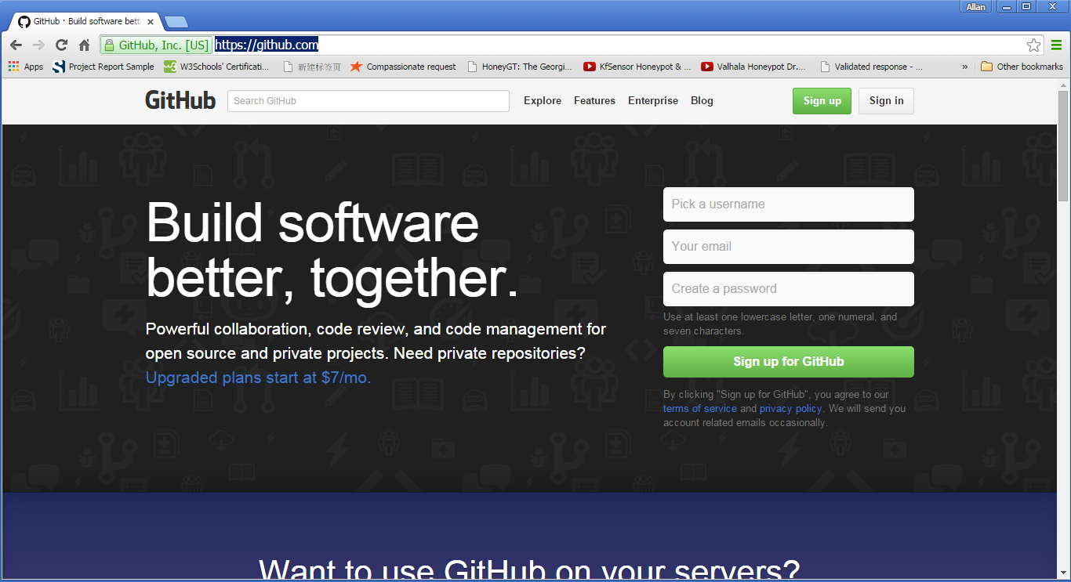

Click on the “Sign up for Github” button

Step 2.

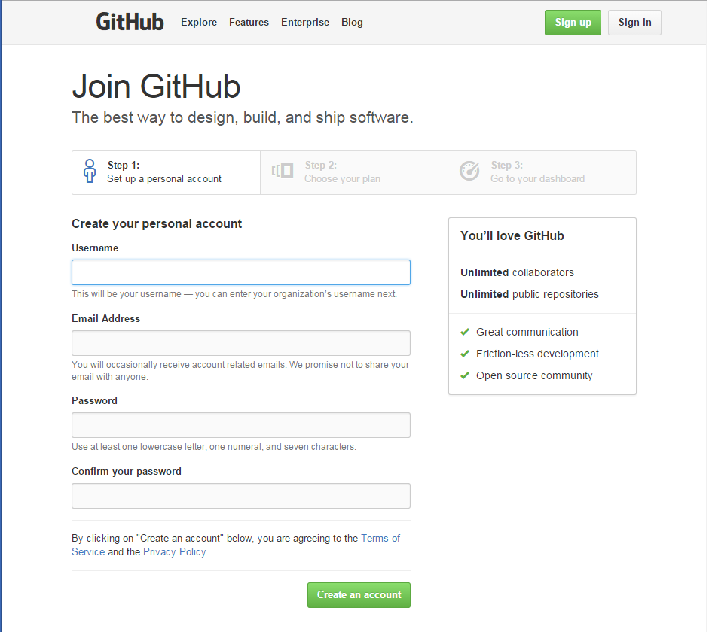

Enter username, email address and password to create the personal detail.



Choose the free account and click “finish sign up” button to complete the setup.

**2. Upload file**

After completing the setup and registration, the site will redirect you to your main page. In order to create a web site, a repository needs to be created.

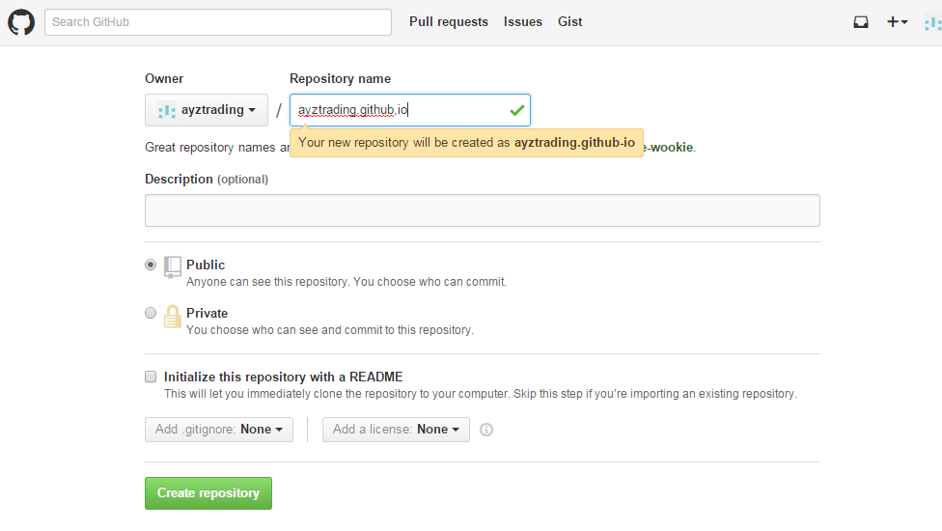

Please follow the instruction carefully or you will not be able to show the web site.

1. The repository name must follow this format:

(username).github.io

1. Ensure that public is checked (private is not available to free account)
2. Check the Initialize this repository with a README

**3. Upload by application**

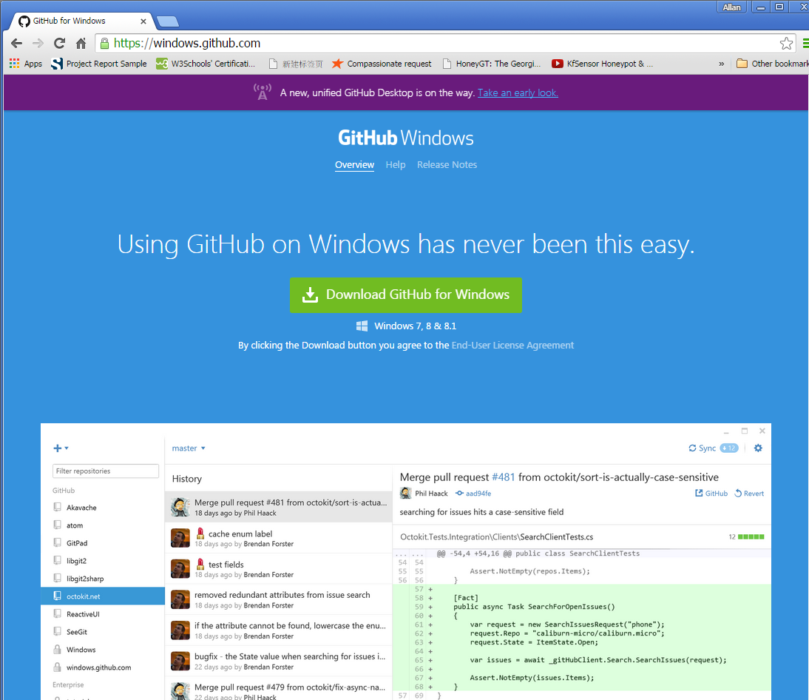

Download the Github by clicking the green button in the middle of the page and download the binary file to your local drive.

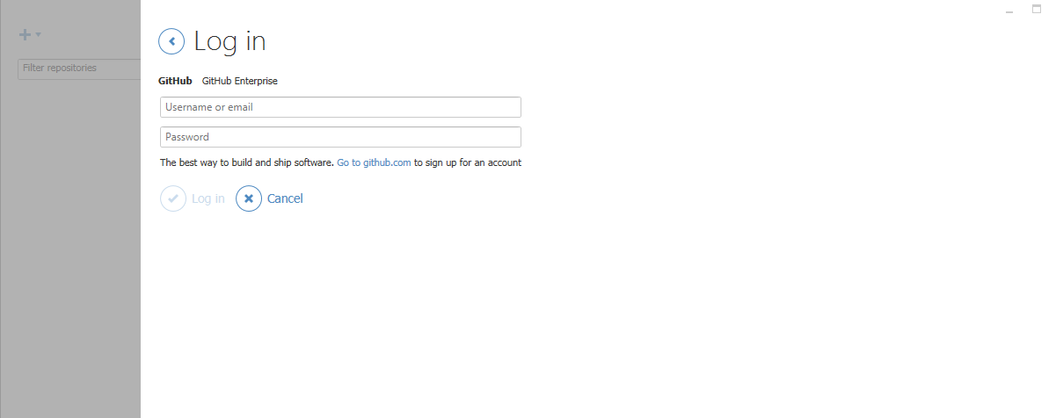

After download and install the application, the github will prompt you to enter your username and password of your github account.

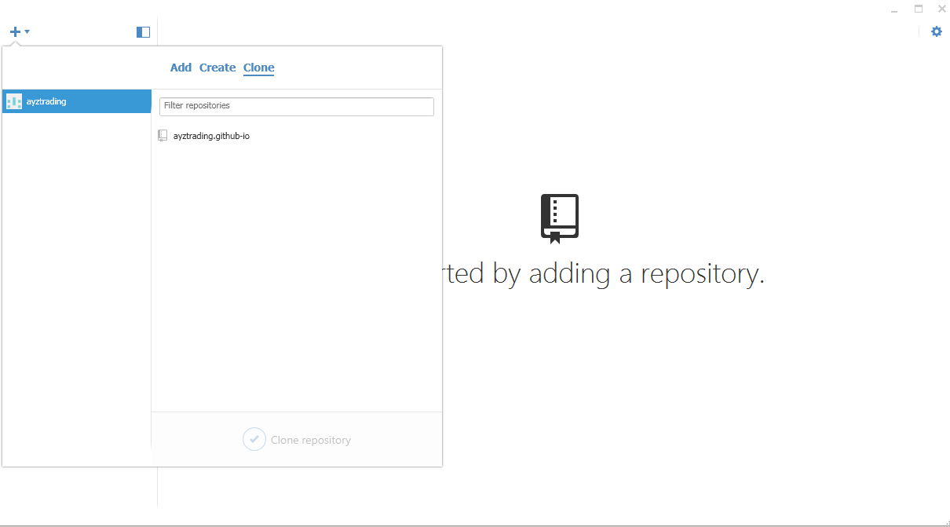

After log into the account, repository need to be cloned onto the computer. Click the plus button (+) on the top left corner of the application. A dialog box to add, create or clone repository will reveal. Select clone. The application will search your github account and display the available repository.

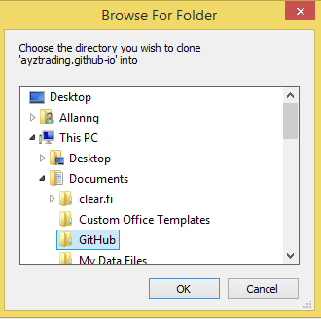

The application will prompt for the repository to be saved locally.

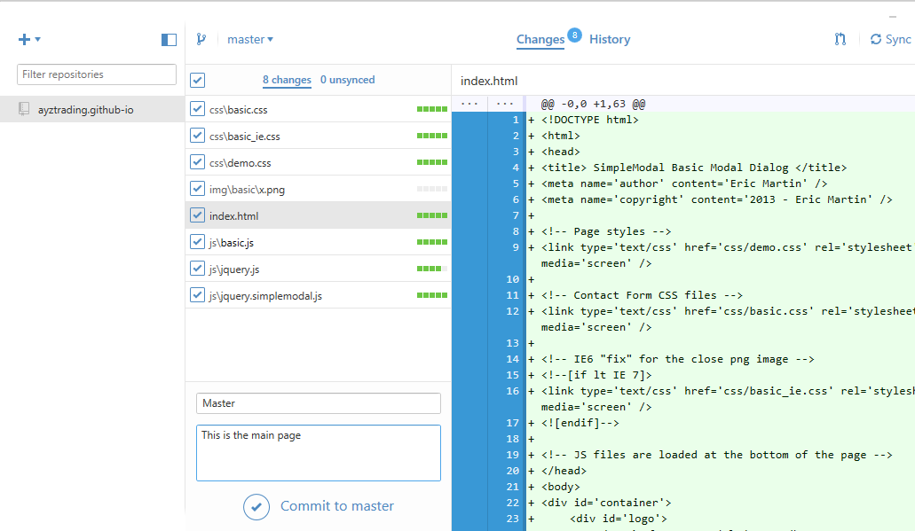

Files need to be uploaded into the selected repository have to be placed into the github directory. The files in the github directory displays in the application. Enter description for the file and then click “commit to master” button below to confirm the changes.

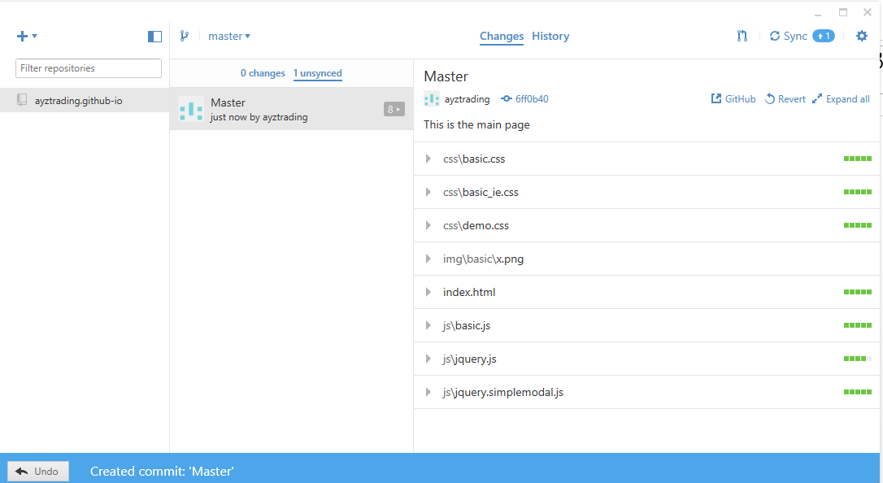

Github for windows allows user to undo the commitment by clicking the undo button located at the bottom left of the application if there is mistake or change of mind. Once everything are confirmed, click on the sync button on the top right of the application.

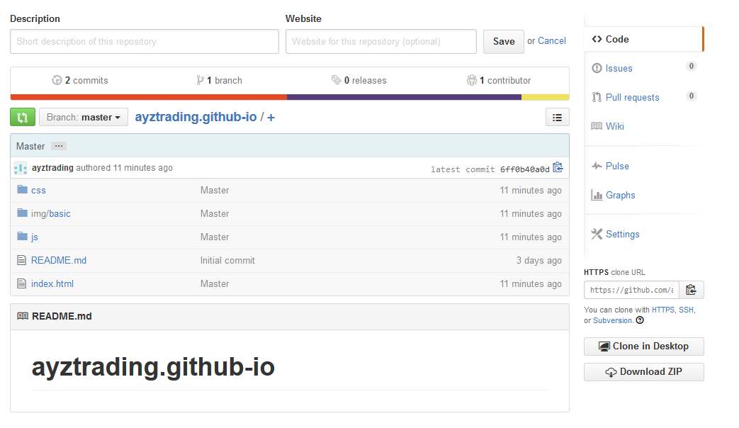

The files uploaded into github is reveal under the selected repository.

1. **Upload using Command Line**

Files can also be uploaded using git shell.

First setup the user name and email address by typing these commands:

1. Git config --global user.name “(type your username here)”
2. Git config –global user.email “(type your email here)”

Use git clone to copy the directory of specific repository to the local drive.

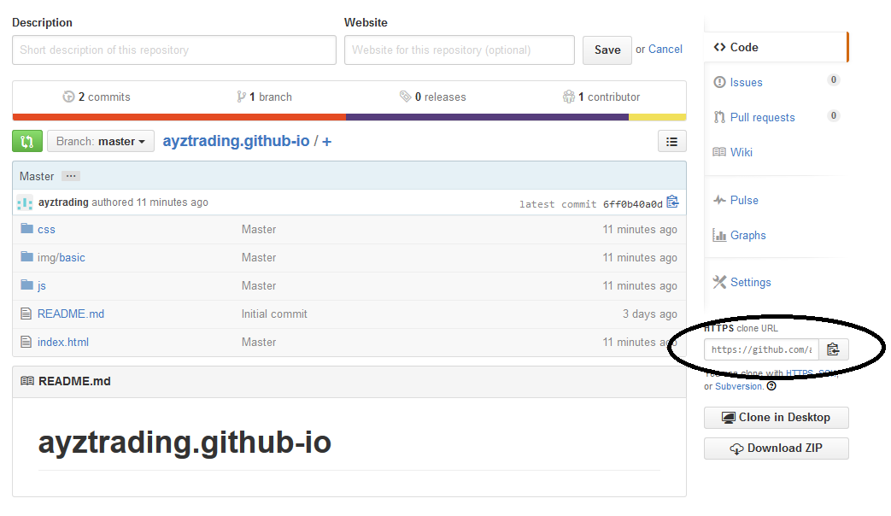

The link for the clone can be found at the right side of the repositary page. Select the https link and copy it. Type the following command into git shell:

Git clone (paste the link here)

Ps: in order to paste into git shell. Move the cursor to the top of the shell application, right click. Go to edit and then paste.

Once the clone process is being done. You can add files into the repository directory in the local drive. In order to ensure that you add to the correct directory, enter this command:

cd (folder name)

git status

This will give you that status the file in the directory.

You have to use these set of commands to uploaded the file into github.

1. Add the updated file.
   1. git add (updated file name)
2. Commit the file
   1. git –m “update files”

-m means add message to the commit.

1. Upload the changed file
   1. git push –u origin master
   2. enter username
   3. enter password

Reference:

1. Hosting Static Sites on Github for Beginners <http://phuse.ca/hosting-static-sites-on-github-for-beginners/>
2. How to Host your Webpage on GitHub in less than 5 minutes https://www.youtube.com/watch?v=rRGrT0wsJxI

`